10.5" x 0.7" slumped plate glass mirror, 5 lbs
finished with 9 micron aluminum oxide Oct 28, 2012
Polishing/Parabolizing Log:
4-21-2013: 10-15 min of polishing. Shine on surface; figure OK.
4-22-2013: 45 min of polishing. Tool working to fullsized shape. Strokes 1/3 long, little side swing. Haze gone. Oblate spheroid with high point at 90%.
4-23-2013: 45 min of polishing. Total polish time is 1:45hr. Longer strokes (1/3-1/2) with almost no side swing. Figure spherical with modest turned edge. Initial laser pointer test on surface reveals heavy scatter in center, tad less at edge.
4-24-2013: 30 min of polishing. Total polish time is 2:15hr. Strokes as before. Laser pointer test shows significantly less scattering.
4-25-2013: 30 min of polishing. Total polish time is 2:45hr. Strokes as before. Laser pointer test shows about the same scatter. Figure is slight oblate spheroid with small gentle turned edge.
4-26-2013: 45 min of polishing. Total polish time is 3:30hr. Strokes as before. Laser pointer scattering near edge becoming dim; some at center.
4-27-2013: 1 hr of polishing. Total polish time is 4:30hr. Strokes as before. Still scattering more or less evenly across the surface.
4-28-2013: 30 min of polishing. Total polish time is 5hr. Strokes as before. Laser pointer test shows underlying scatter, though less than before. Rolled edge ~ 1/8 inch wide.
4-29-2013: 1 hr of polishing. Total polish time is 6hr. Strokes as before. Laser pointer test shows background scatter largely gone, some scatter from points (pits, cerium oxide?) on surface. Rolled edge nearly gone - 1/16 inch extent and barely rolled. Temps for all sessions in low 60's F.
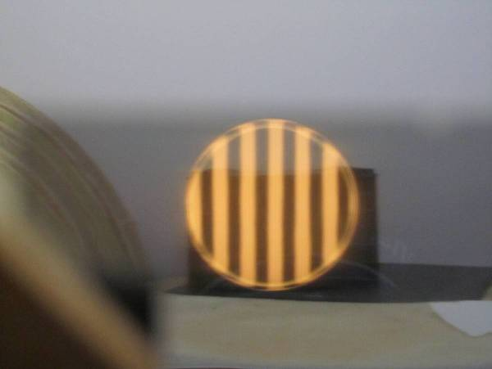
End of polishing. Begin prep for parabolization by bringing extreme edge into line.
4-30-2013: 30 min of polishing. Long strokes no side swing. Turned edge worse. No trace of laser pointer scattering.
4-30-2013: 30 min of polishing. Short strokes no side swing. Turned edge better; back to how it was.
5-1-2013: 30 min of polishing. Short strokes as before. Turned edge better; just a smidgeon remaining.
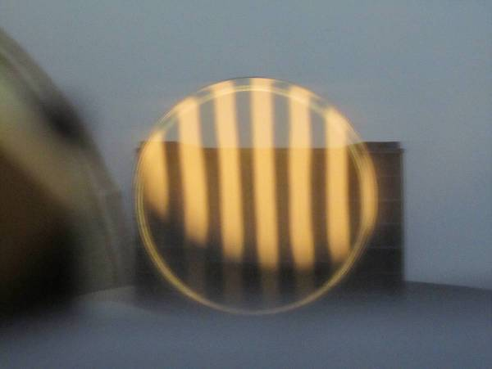
5-2-2013: 30 min of polishing. Very short strokes no side swing as last session. TDE about the same.
5-4-2013: 30 min of polishing. Very short 1/8 long strokes with 1/3 side to side swing and slight accentuated pressure on mirror’s edge when over the lap; lap’s edge not fully in contact. TDE less; very minimal.
5-5-2013: 70 min of polishing. As above. No change in the edge really after several hours of polishing. Turned edge is about 1/32 inch wide and fairly deep. If masked or beveled off, the loss of surface area is about 2%. Finally, in some cases the turned edge goes away with parabolization.
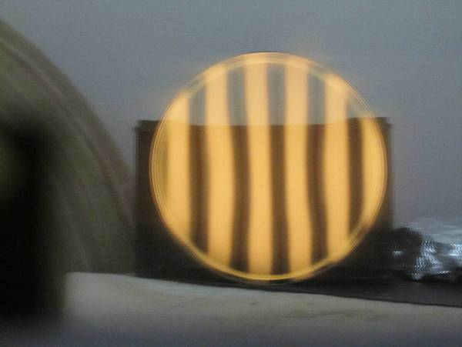
End of preparation work on edge. Beginning parabolization.
5-5-2013: 30 min of extreme choral strokes to deepen the center. Center is deepening, expected roughness in the center because of the pressure and because the glass is plate glass; TDE appears less.
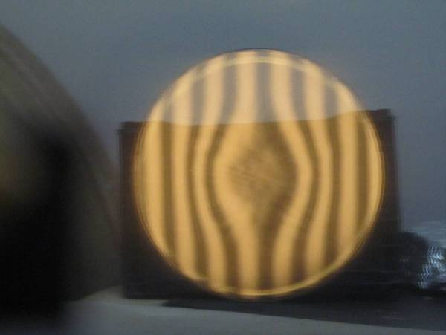
5-6-2013: 20 minutes of very long strokes center over center. Parabolization pushing outward from center.
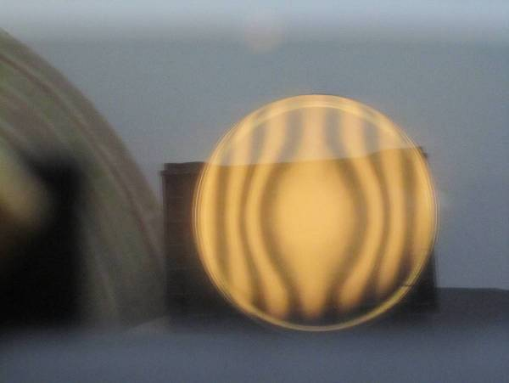
5-7-2013: 20 min very long strokes, center over center.
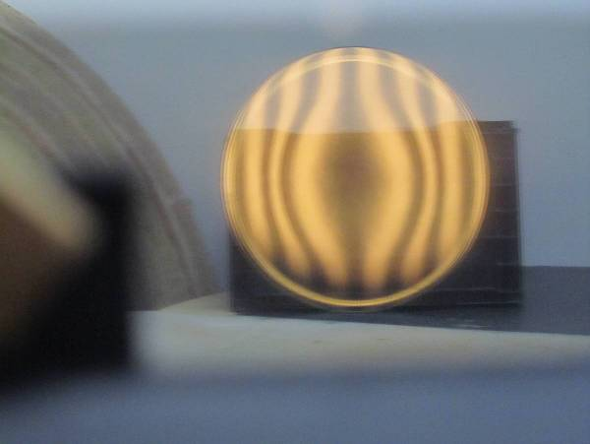
5-8-2013: 30 min of very long strokes center over center.
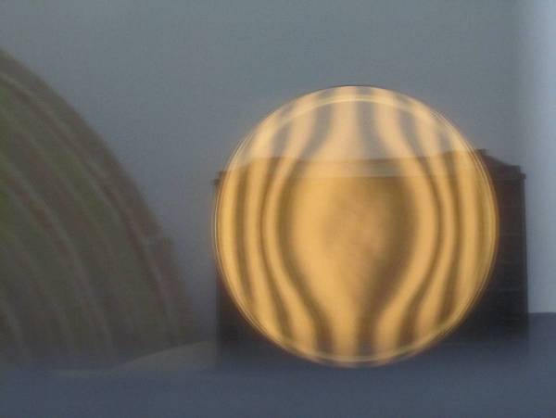
5-9-2013: 20 min of very long strokes center over center.
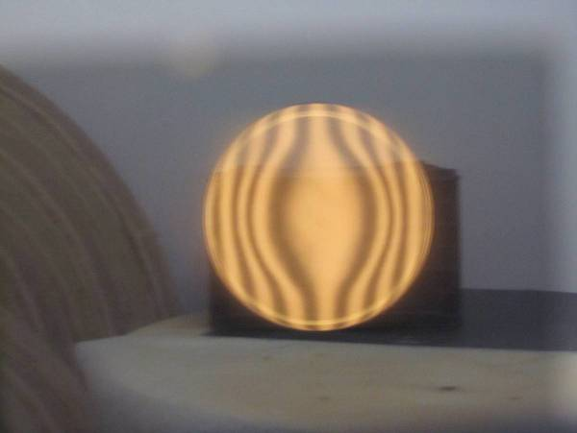
5-11-2013: 30 min of very long strokes center over center over new deepened ‘parabolizing’ pitch lap. Curve coming along.
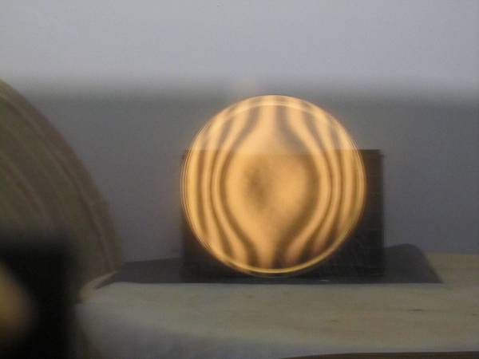
5-11-2013: 20 min of very long strokes center over center over new deepened ‘parabolizing’ pitch lap. Switching to outside of radius of curvature Ronchigram which gives more sensitivity to the edge zones. Mirror reaching at-a-glance-parabolization. From this perspective, the 60% zone is too deep and the 80% zone too shallow.
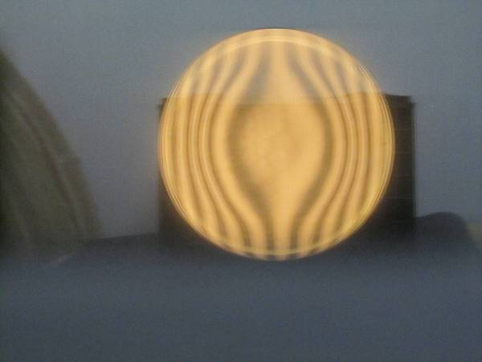
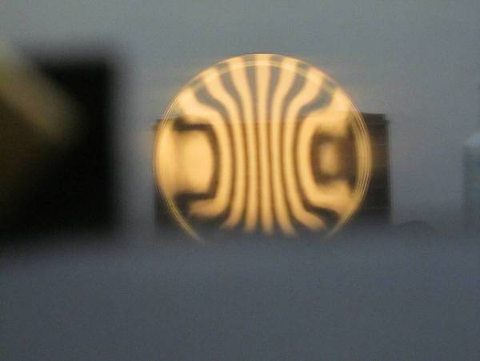
5-14-2013: 20 min 1/3 long strokes with minimal side swing on lap with 60% zone cutaway. Some subtle changes, no real improvement.
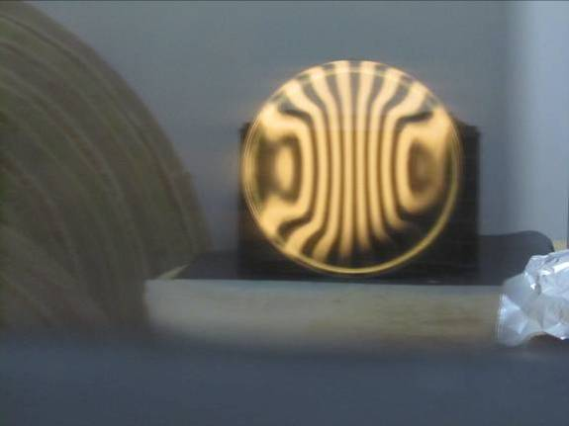
5-14-2013: 20 min shorter strokes so that the end of the stroke was over the 70% zone and the side swing left the 90% zone over the lap’s edge. Curve much smoother.
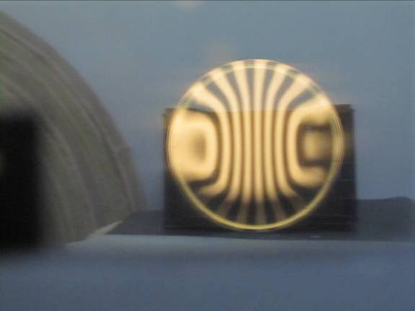
5-15-2013: 15 min short strokes with lap cut away at 60%. This to keep parabolization but remove the kink. Still a bit of kink remains at the 60% zone.
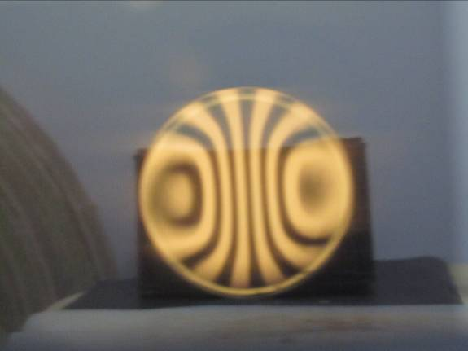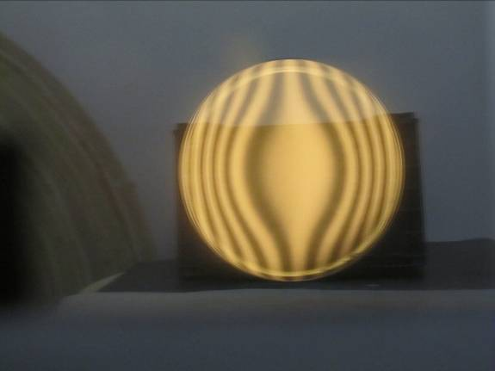

7-6-2013: Brought pitch lap into contact after a 2 month hiatus. A masking tape rim along with hot water from a tea pot along with pushing the pitch lap in from the edge with a bit of cutting channels in the middle 70% brought the lap into contact after 30 minutes of effort.
7-7-2013: 15 minutes very short strokes no side swing on lap cut away at 50% zone. Result is little change. Try little longer little wider strokes to knock down the 80% while trying to lift up the 60% zone.
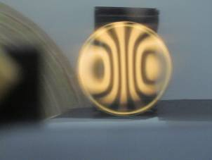
7-7-2013: 15 minutes 1/3 long strokes with side swing on lap cutaway at 50% zone. Not much change. Continue until a difference.
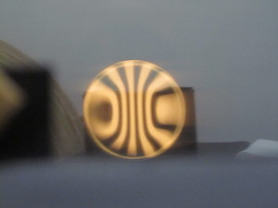
7-7-2013: 15 minutes short strokes with side swing. Worse: 50% zone kinked and edge zones going flat. Need to adopt parabolizing lap with long strokes, side swing focused on 80% zone and cut away 50% zone.
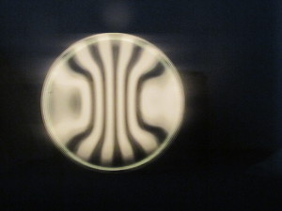
7-7-2013: 15 minutes long strokes with side swing so that the pitch’s edge hit the high 80% zone, along with pitch cut away at the 50% zone. Better.
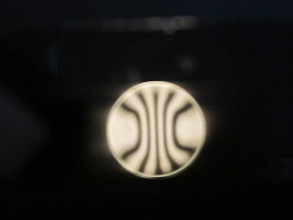
7-7-2013: 15 minutes as above long strokes with side swing so that the pitch’s edge hit the high 80% zone, along with pitch cut away at the 50% zone. Not much change. At this point the undercorrection is worse than the kink; so long strokes with some side swing to deepen the 80% zone.
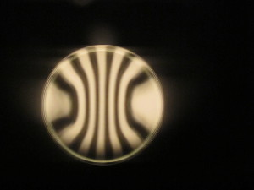
7-7-2013: 15 minutes of very long strokes with some side swing on lap with 50% zone cut away. Better.
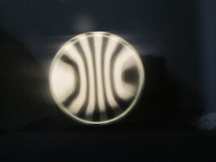
7-8-2013: 20 minutes of very long strokes with some side swing on mild parabolizing lap with 50% zone cutaway. Smoother bands but undercorrected.
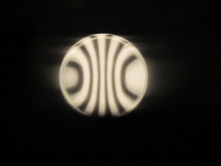
7-8-2013: 15 minutes very long strokes no side swing. Better – more correction, bands smooth. Still need significantly more correction.
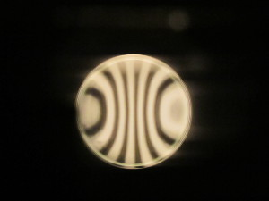
7-9-2013: 15 minutes very long strokes no side swing on mildly parabolizing lap. No side swing because that will preferentially dig out the center. A hint more parabolized – much more to go compared to how much accomplished in this session.
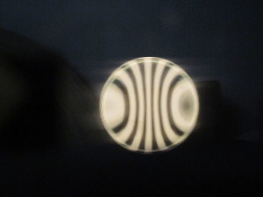
7-9-2013: 20 minutes very long strokes no side swing on mildly parabolizing lap. Closer – distinctly more parabolization than before.
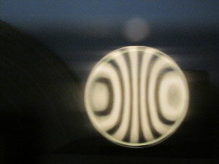
7-10-2013: Using precision offsets from the radius of curvature and comparing to the computer generated Ronchigrams, I judge that the mirror is slightly undercorrected in the outer zones.
7-11-2013: 12 minutes long strokes no side swing on standard lap (not heavily parabolizing). A bit more parabolized, a bit more to go. Turned edge shrinking.
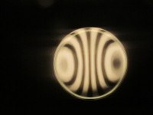
7-11-2013: 12 minutes long strokes no side swing on standard lap. Maybe less parabolization and hole starting in center. Lesson learned: the standard lap is not a good idea; need a strongly parabolizing lap to continue.
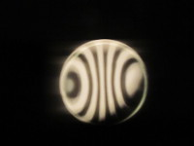
7-12-2013: 15 minutes very long strokes with some side swing on parabolizing lap. Better: smoother bands, turned edge disappearing, a bit more correction, but still need more parabolization.
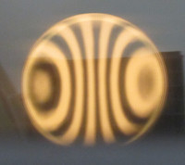
7-12-2013: 15 minutes very long strokes with some side swing on parabolizing lap. Close to required parabolization, turned edge shrinking, smooth bands.
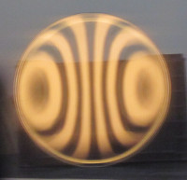
7-14-2013: Initial star test at 3mm exit pupil is unexpectedly good: looks closely corrected with no zones. But focus is 1/2 inch further in than expected so need to adjust star test rig and try again more rigorously.
7-24-2013: Star test focuses to a point with slight undercorrected figure.
7-27-2013: 5 min very long strokes no side swing on parabolizing lap. Ronchi bands very smooth but do look overcorrected at the extreme edge. RC=58 3/8”. Star test shows overcorrection to the extent that the test star does not quite focus to a point.
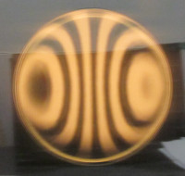
7-28-2013: 4 min short strokes on reverse parabolization lap where the pitch contact concentrates in the 70% zone and tapes towards the edge with no contact in the central zones. Ronchigram shows less correction. Star test much better: now focuses to a pinpoint with slight overall correction (TDE).
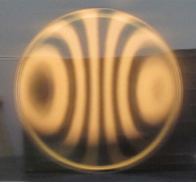
7-29-2013: 2 min short strokes on reverse parabolizing lap. A hint of less correction in outer zones – 2 minutes polishing makes a difference. Ronchi bands look to need a touch more flatness in the 30-60% zones. The strongly curved bands are very touchy when it comes to the exact RC offset. Changing to an offset of 0.348” seem to matches the bands the best. Star test (passes the focus to a point test) shows a bit of overcorrection overall and overcorrected 80% zone.
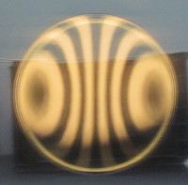
7-30-2013: 1 min short strokes on reverse parabolizing lap with 80% zone on lap cut away, so main contact was on the 60-70% with a bit on the 90% zones. Star test shows a touch of overcorrection, about the same as last night’s star test and a low 80% zone, less than last night.
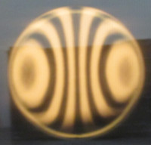
7-31-2013: 1.5 min as above (short strokes on reverse parabolizing lap with 80% zone on lap cut away). Kinks in bands appearing (80% too curved, 60% not curved enough), TDE. Not completely clear if kinks are caused by the general zoniness of the pitch lap contact or by the lap’s cutaway 80% contact zone.
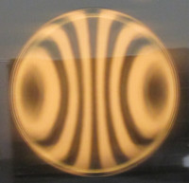
8-1-2013: 1 minute 1/3 stroke no side swing on standard lap to flatten the center a bit. Maybe a touch flatter with some kinkiness at the 80% zone.
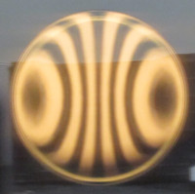
8-1-2013: 1 minute 1/3 stroke no side swing on standard lap to continue flattening center and smoothing bands. Looking very slightly better.
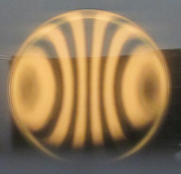
8-2-2013: star test shows mild overcorrected 80% to edge zone, undercorrected center to 60% zone.
8-3-2013: 1 min long strokes no side swing on parabolizing lap. Infinitesimally smoother bands with worst kink at 80% zone and high zone at 60%.
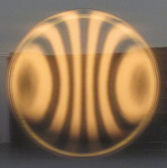
8-3-2013: 45 sec small circular strokes on lap with concentrated contact at 30-70% zones. A touch rounder at the 60% zone. Star test shows more undercorrection than before with edge defect less or smoother.
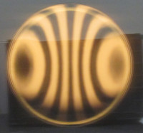
8-4-2013: 1.5 min strokes as above: small circular strokes on lap with concentrated contact at 40-60% zones. Smoother but seem to be removing correction.
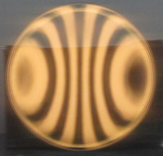
8-4-2013: 2 min very long strokes no side swing on mild parabolizing lap. A bit more correction.
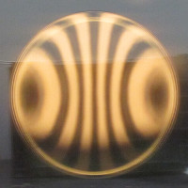
8-4-2013: 1.5 min medium long strokes, no side swing on mild parabolizing lap, idea being to preferentially correct the mid zone as opposed to the center zones. Appears to be heading in a good direction: more correction overall (slight kink moving inward slightly). Star test focuses to a dot, but shows two zones: a slightly overcorrected 80-100% zone and an undercorrected center to 80% broad zone.
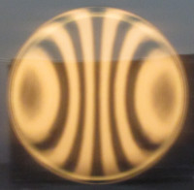
8-5-2013: 1.5 min long strokes no side swing on lap with outer edge cut away along with center. The idea is to move the peak of the curve inward, adding more correction to the 30-85% zones. 85% zone a touch smoother, a hint of more correction in the outer zones.
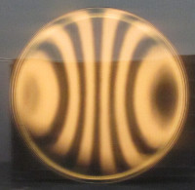
8-5-2013: 2 min as above, long strokes no side swing, on lap with center 30% cut away and outer 15% cut away. A touch better in that the 85% kink is ever so slightly smoother and perhaps a touch more correction overall.
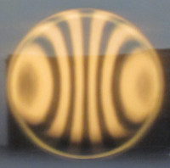
8-5-2013: 1 min very short circular strokes on lap with contact on 70-85% zone.
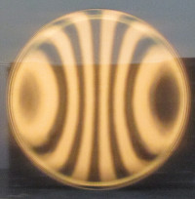
8-5-2013: 1 min very short circular strokes on lap with contact on 70-85% zone. Did push the 70-85% zone down a bit.
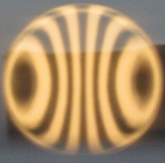
8-5-2013: 1 min very short strokes no side swing on lap as above (contact at 60-85%). Kink moved inward very slightly, overall correction less.
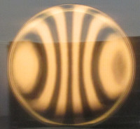
8-5-2013: 2 min very long strokes on mild parabolizing lap. Infinitesimally more correction.
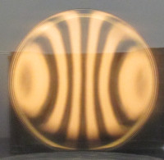
8-5-2013: 2 min very long strokes on mild parabolizing lap. Infinitesimally more correction.
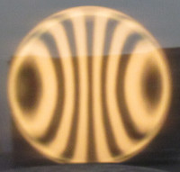
8-5-2013: 3 min very long strokes on mild parabolizing lap. Infinitesimally more correction.
8-5-2013: 3 min very long strokes on parabolizing lap with 85% zone cut away. A bit more correction.
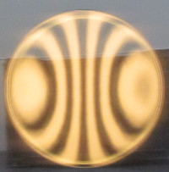
8-5-2013: 2 min very long strokes on parabolizing lap with 85% zone cutaway (no side swing as always). A bit more correction. Interesting that correction is stronger when the mirror is first placed on the mirror test stand than a few minutes later. The mirror is overcorrected when warmed and cooling to match the room’s temp. Star test shows turned edge, undercorrected center to 50% zone.
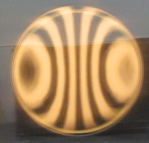
8-5-2013: 2.5 min very long strokes no side swing on strongly parabolizing lap with 85% zone cut away. Ronchigram shows a bit more correction. Star test shows undercorrected 50% zone, less undercorrection towards center.
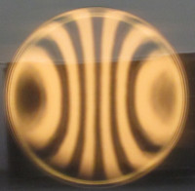
8-5-2013: 1.5 min on standard lap with irregular contact ½ long strokes with accentuated pressure on mirror’s 50% zone followed by 1 min very long strokes no side swing. Ronchigram very similar, maybe a tad more curve in the 60% zone. Star test shows some undercorrection in central zones and a turned edge.
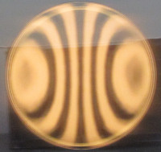
8-5-2013: 2 min very long strokes no side swing on mild parabolizing lap. Star test still shows some undercorrection towards the center.
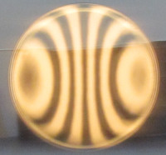
8-5-2013: 2.5 min very long strokes no side swing on mild parabolizing lap. Ronchigram shows a tiny bit more correction. Star test shows just a smidgeon of undercorrection – pretty close now.
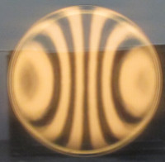
8-6-2013: 1.5 min very long strokes no side swing on mild parabolizing lap. Ronchigram not much different than last session, though more corrected than two sessions ago. Star test same as previous – slightly undercorrected center to 80% zone, very slightly overcorrected 85% zone. Noticed that mirror can be flexed into astigmatic view by holding up an edge support.
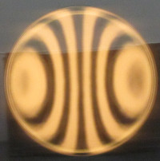
8-6-2013: 2 min very long strokes, no side swing, on parabolizing lap with 85% zone cutaway. Ronchigram shows a bit more correction. Star test shows undercorrection though slightly less then previous session.
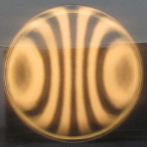
8-6-2013: 3 min as above (very long strokes, no side swing, on parabolizing lap with 85% zone cutaway). Ronchigram shows a tad more correction with bands looking smooth and of proper shape. Star test shows less undercorrection in that the diagonal shadow breakout below focus (overcorrected position) is now visible.
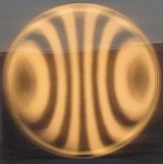
8-6-2013: 3 min as above (very long strokes, no side swing, on parabolizing lap with 85% zone cutaway). Ronchigram shows more correction with bands looking smooth and of proper shape. Star test shows very slight overcorrection in center, very slight undercorrected 60% zone, turned edge.
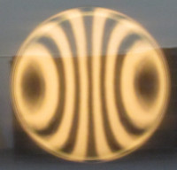
8-6-2013: 45 sec 2/3 long strokes, no side swing, on standard lap in effort to bring down correction in center and bring up correction at 50% zone. Quick glance at Ronchi test looks smooth, little changed from last session – really relying on star test now. Star test shows diagonal shadow breakout the same in both directions but with the above focus position showing a brighter ring around the diagonal and the below focus position showing a brighter ring on the outside meaning that the outer 15% is very slightly overcorrected and the inner 85% is very slightly undercorrected. Star test pattern improves as the mirror cools to ambient air temperature. These issues are very slight and unlikely to improve so time to call the mirror finished.
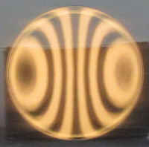
8-11-2013: Ground off dried cerium oxide on side of blank and freshened up the bevel. Final Ronchigrams:
