6" x 0.95" flat black Pyrex mirror, 2 lbs
finished with 9 micron aluminum oxide Oct 28, 2012
Polishing/Parabolizing Log
4-21-2013: 10-15 min of polishing. Shine on surface; figure OK.
4-22-2013: 45 min of polishing. Tool working to oversized shape. Strokes 1/3 long, little side swing. Haze gone. Oblate spheroid with high point at 90%.
4-23-2013: 45 min of polishing. Total polish time is 1:45hr. Longer strokes (1/3-1/2) with almost no side swing. Oblate spheroid almost gone. Initial laser pointer test on surface reveals heavy scatter.
4-24-2013: 30 min of polishing. Total polish time is 2:15hr. Strokes as before. Laser pointer test shows minimal scattering near edge, none near center.
4-25-2013: 30 min of polishing. Total polish time is 2:45hr. Strokes as before. Laser pointer test shows minimal scattering at extreme edge, none near center. Straight Ronchi bands to extreme edge.
4-26-2013: 45 min of polishing. Total polish time is 3:30hr. Strokes as before. Laser pointer test shows light scattering at extreme edge.
4-27-2013: 1 hr of polishing. Total polish time is 4:30hr. Strokes as before. Laser pointer test shows smattering of scatter at extreme edge.
4-28-2013: 30 min of polishing. Total polish time is 5hr. Strokes as before. Laser pointer test shows a few scatter points: could be pits or cerium oxide particles.
End of polishing. Begin figure preparation for parabolization by straightening extreme edge.
4-29-2013: 30 min of polishing using longer (almost 1/2 strokes, little side swing). Turned edge gone.
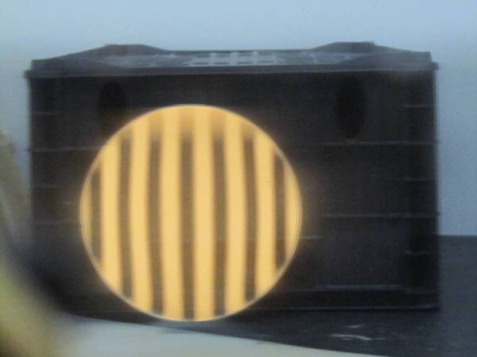
End of figure prep. Begin parabolization.
4-30-2013: 15 min of extreme chordal strokes (mirror center over tool edge). Smooth hole forming in center of mirror.
5-1-2013: 15 min combined where 5 min were extreme chordal strokes as before and 10 min were very long center over center strokes (since the edge of the pitch lap became depressed slightly thanks to the pressure of the chordal strokes. Not a lot of change: hole in center about same depth but spread out a tad more.
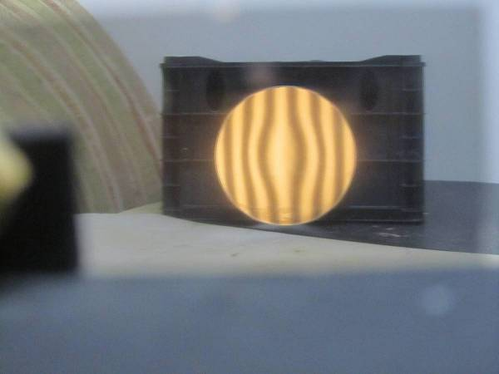
5-2-2013: 15 min of extreme chordal strokes. More parabolization in center.
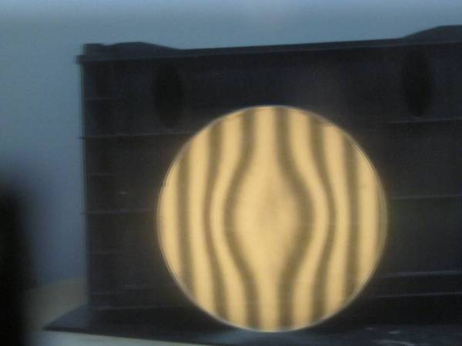
5-5-2013: 15 min of very long (always mirror on top) center over center strokes. Central hole deepening and spreading a bit towards edge.
5-6-2013: 20 min very long strokes. Parabolization pushing towards edge.
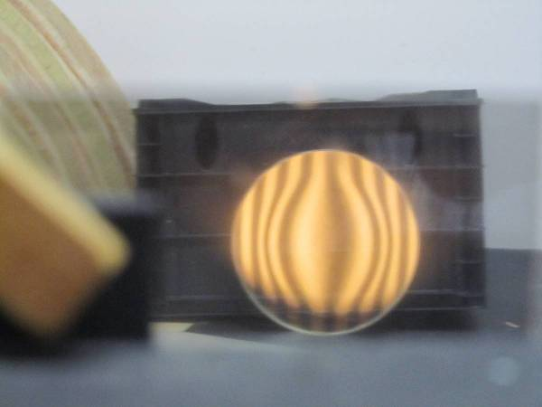
5-7-2013: 20 min very long strokes, center over center.
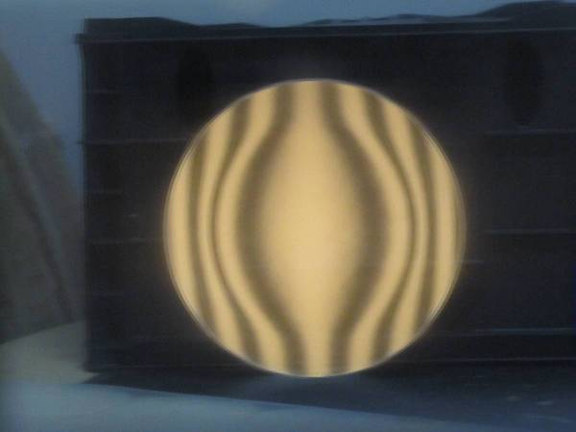
5-8-2013: 20 min of very long strokes center over center.
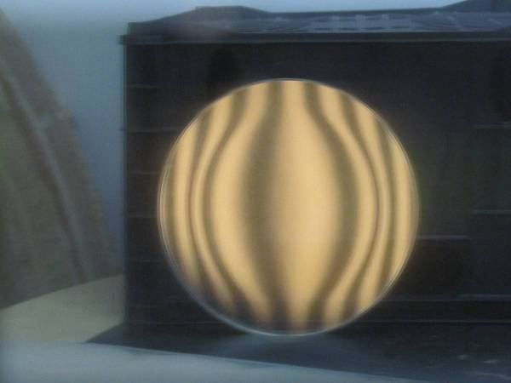
5-9-2013: 15 min of very long strokes center over center on standard lap (equal contact from edge to center). Idea is to avoid overcorrecting. The standard lap helped bring correction to the edge but it also flattened the center.
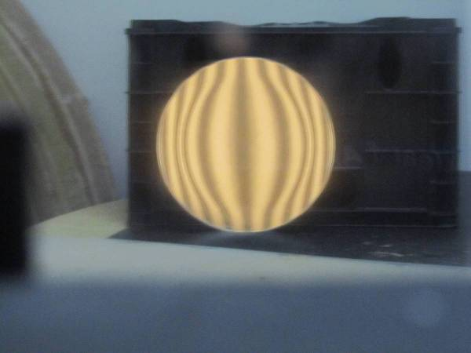
5-10-2013: 20 min of very long center over center strokes; back to parabolizing lap. Parabolization reaching edge. Switching to outside of radius of curvature which is more sensitive at the mirror’s edge. From the perspective of outside RoC, the 60% zone is too low and the 85% zone is too high. Time to adjust the curve by altering the pitch lap.
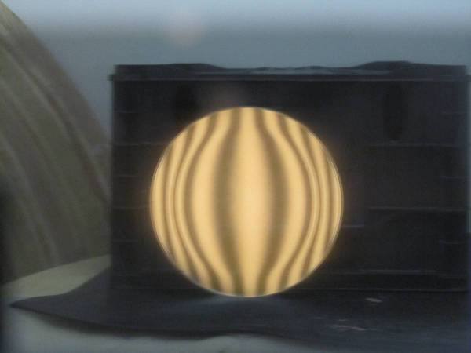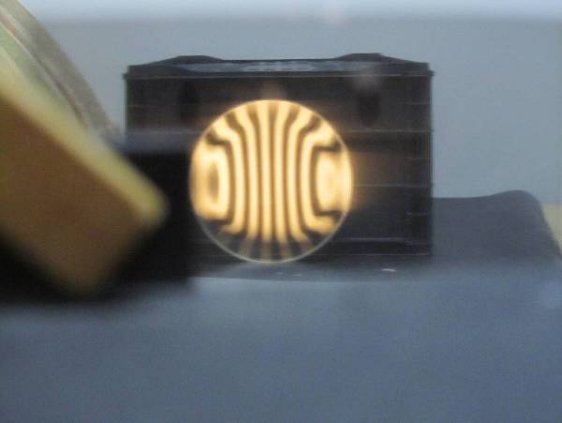
5-11-2013: 15 min of ½ center over center with pitch lap cut away at the 60% zone. Edge a tiny bit better, 60% zone about the same.
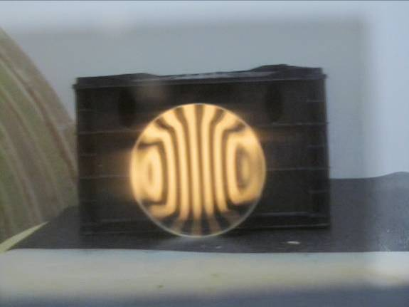
5-12-2013: 15 min of shortened strokes so that the 70% zone of the mirror was over the edge at the beginning and end of each stroke with a little side swing so that the 90% zone of the mirror was over the edge of the lap. This with a lap with the 60% zone cutaway. Edge maybe a tad smoother; kink a touch less but persists.
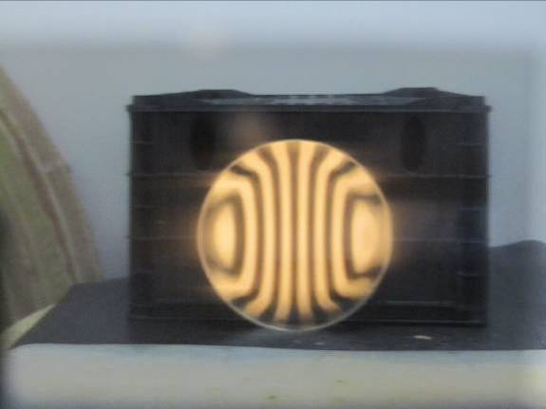
5-12-2013: 15 as above. Curve looking better. Overall correction in the ballpark at a glance.
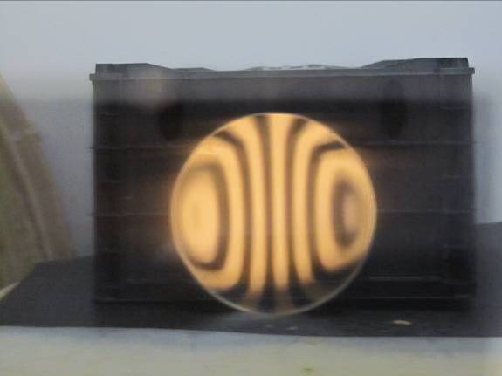
5-16-2013: 15 min short strokes over lap with 70% zone cutaway. This to preserve the parabolization (not hitting the 70& zone) and to wear down the center and edge so as to remove the kink.
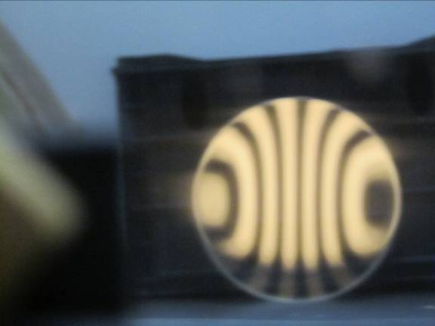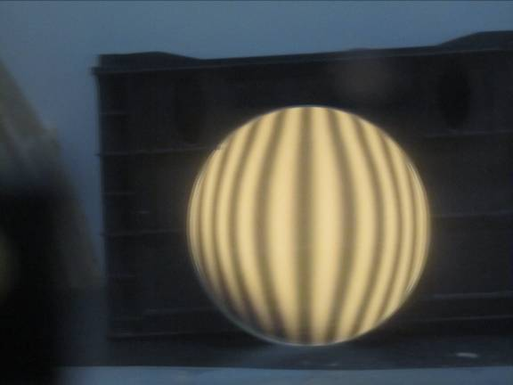
7-6-2013: Brought pitch lap into contact after a 2 month hiatus. A masking tape rim along with hot water from a tea pot along with pushing the pitch lap in from the edge brought the lap into contact after 30 minutes of effort.
Using precision offsets from the radius of curvature and comparing to the computer generated Ronchigrams, I judge that the mirror is quite close, perhaps slightly overcorrected.
7-14-2013: Initial star test at 3mm exit pupil shows overcorrection; all zones do not quite focus simultaneously. Overcorrection perhaps slightly worse in mid-zones.
7-15-2013: 6 minutes medium long strokes no side swing on standard lap. 80% zone deeper, a hint of less correction.
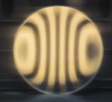
7-15-2013: 6 minutes medium long strokes no side swing on standard lap with 80% zone cut away. Not much change, maybe less correction.
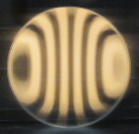
7-15-2013: 6 minutes 1/3 long strokes no side swing on standard lap with 80% zone cut away. 80% zone relatively deeper, less correction. Star test shows that the light barely focuses into a pinpoint now (so overall correction closer) but with heavily overcorrected mid-zones.
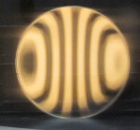
7-17-2013: 3 minutes with spinning strokes concentrating the mirror’s 80% zone on the lap’s edge. Hypothesis is that the 80% zone needs more polishing so that the band is driven smoother. Little change.
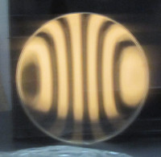
7-17-2013: 5 minutes with short strokes with accentuated pressure on mirror’s 80% zone (MOT as always). Smoother bands.
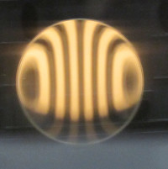
7-17-2013: 8 minutes with short strokes with accentuated pressure on mirror’s 80% zone (MOT as always). Kink worse and correction lost. Looks like the radius of curvature is being driven shorter, leaving the edge longer.
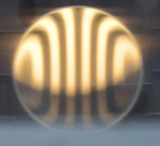
7-17-2013: 10 minutes ½ long strokes with no side swing. Hypothesis is that this will smooth out the edge zones. Correction being removed from center outward. So didn’t smooth out edge zones.
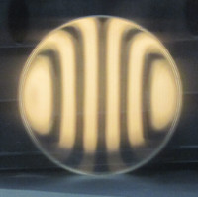
7-18-2013: giving up and returning to spherical. 30 min short strokes. Maybe half of parabolization gone.
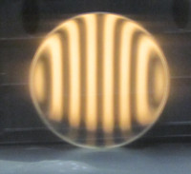
7-18-2013: 30 min short strokes. A bit of turned edge remains.
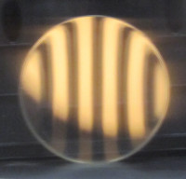
7-19-2013: 1 hr of very short strokes with side swing limited to the edges of the lap. A bit of TDE remains. Perhaps some side swing is contributing to the TDE.
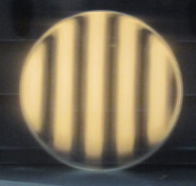
7-20-2013: 1 hr of 1/3 strokes with no side swing at all on standard lap. A thin TDE remains. Probably as good as it will get. Total of 3 hrs spent returning to spherical.
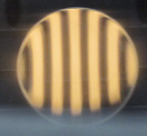
7-20-2013: 50 minutes very long full length strokes, no side swing, on parabolizing lap. I decided that the 5 minutes at the start of the 1st parabolization run wasn’t needed.
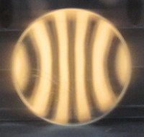
7-21-2013: 20 minutes 2/3 long strokes with no side swing on parabolizing lap. A bit more parabolization.
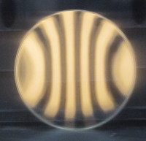
7-21-2013: 15 min 2/3 long strokes with no side swing on parabolizing lap. A bit more correction; kink worsening. Unlike first time through, start fixing kink before reaching a great deal of parabolization, knowing that this action will add correction.
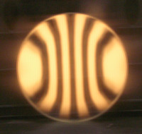
7-21-2013: 20 min very short strokes, no side swing on lap with 60% zone cut away. Kink much smoother.
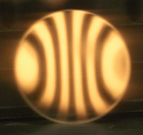
7-21-2013: 15 min very short strokes, no side swing on lap with 60% zone cut away. Smoothly undercorrected, a desirable position. Looks like removing the kink adds a touch of correction.
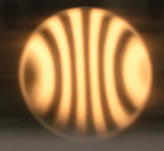
7-22-2013: 15 minutes short strokes (1/4 long) no side swing on parabolizing lap with 60% zone cut away. A bit more parabolization in the outer zones.
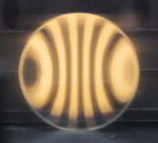
7-22-2013: 15 minutes short strokes no side swing on parabolizing lap. More correction in outer zones; TDE less; looking closer to ideal. Star test reveals that light focuses to a pinpoint with a slight touch of undercorrection and what looks to be slightly overcorrected outer zones.
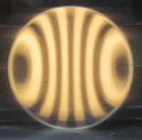
7-24-2013: Star test focuses to a point with slightly undercorrected mid-outer zones and ever so slightly overcorrected center.
7-27-2013: 4 min short strokes no side swing on standard lap with 70% zone cut away. Ronchigram ‘feels/looks’ slightly undercorrected. Star test shows very slight overcorrection.
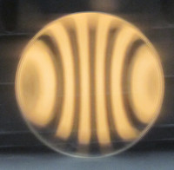
7-28-2013: 2 min short strokes on reverse parabolization lap where the pitch contact concentrates in the 70% zone and tapes towards the edge with no contact in the central zones. Ronchigram shows that correction is slightly less. Star test shows good overall correction with slightly overcorrected 70-80% zone and TDE.
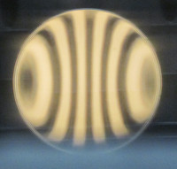
7-29-2013: 1 min short strokes on lap with pitch mildly concentrated towards 80% zone. Bands are more curvy in outer zones. Star test looks very good: excellent overall correction with a touch of overcorrection in the 50-80% zones.
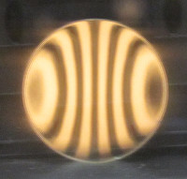
7-30-2013: 30 sec continuing as above (short strokes on lap with pitch mildly concentrated towards 80% zone). Star test really about the same as last night (excellent overall correction with a touch of overcorrection in the 50-80% zones). So I’m calling it a finished mirror.
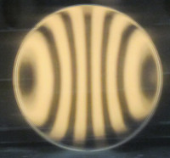
8-11-2013: Ground off dried cerium oxide on side of blank and freshened up the bevel. Final Ronchigrams:
